Towering Pines Camp for Boys

HOW IT WORKS

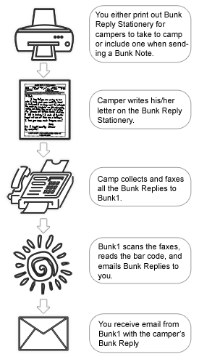

TO GET STARTED

You will need to set up an account with Bunk1 before you can take advantage of Bunk Replies. If you have already set up an account, skip this box. If you have not set up an account…

1. Go to our website at http://www.bunk1rollcall.com/en/i/899/login
2. Click “Register Here”
3. Enter your Invitation Code: UOAUWTKO
4. Fill out all the required information
5. Purchase Bunk Note credits (you will need a credit card)

TO RECEIVE BUNK REPLIES

You must provide your camper with Bunk Reply Stationery to receive Bunk Replies. There are two options:

1. Purchase & print Bunk Reply Stationery when you set up (or renew) your account
2. Attach Bunk Reply Stationery when you send Bunk Notes to your camper

Once your camper receives the stationery, it is up to him/her to write the letter and hand it in to the camp.

FREQUENTLY ASKED QUESTIONS

What does this cost?
It costs a total of 2 credits for you to send Bunk Reply Stationery to your camper and receive a Bunk Reply in return. Alternatively, you can pay a flat fee to pre-print an unlimited amount of Bunk Reply Stationery (before camp starts).

When will I get a Reply from my camper?
You will only receive a Reply from your child once he/she writes the note, turns it in to the camp office, and it is faxed into the system. Some campers will not write a response immediately and some may not write at all. Please be patient.
Why do I have to pay for Bunk Replies?
Your payment helps us cover technology costs, paper, ink, and labor and, more importantly, frees us to do what we do best – be with your kids!

